Main concept:

this is the *first argument* of .call() or .apply() in an indirect invocation

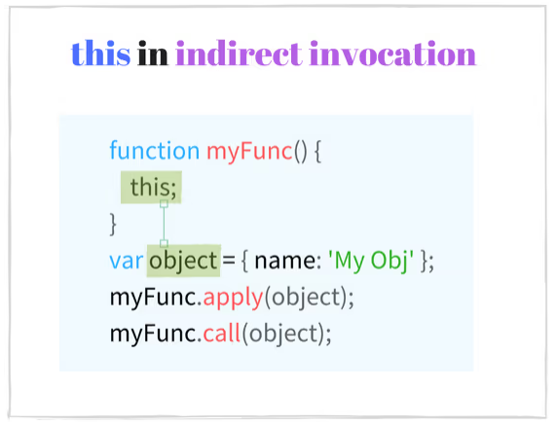

Sample Code:

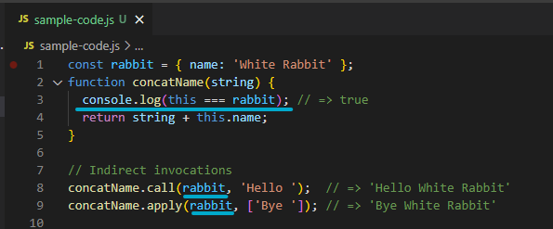

Indirect invocation is useful when a function should be executed with a SPECIFIC context.

ES5 example:

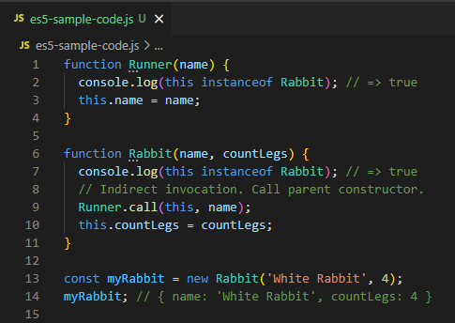

In the constructor Rabbit, there is a method call for Runner where the thisArg === this. First Arg ‘this’ which is the Rabbit will now be the context of invocation for the ‘this’ in Runner constructor!

